**TECHNICAL HUB PROJECT INFO**

***Submitted in accordance with the requirement for the degree of***

# BACHELOR OF TECHNOLOGY

**in**

# COMPUTER SCIENCE AND ENGINEERING

# ELECTRONICS AND COMMUNICATION ENGINEERING

# Submitted By

RUDRARAJU DEVI NISHITHA (21A91A0591)

SATHI SRI LAKSHMI PRASANNA REDDY (21A91A0594)

MAKA NANIBABU (21A91A0526)

GUDALA SNEHA AISHWARYA (21A91A0413)

PASUPULETI NIHARIKA (21MH1A04A8)

KURAKULA MANASA (21MH1A0497)



**DEPARTMENT OF COMPUTER SCIENCE & ENGINEERING**

**ELECTRONICS AND COMMUNICATION ENGINEERING**

**ADITYA ENGINEERING COLLEGE (A)**

**Approved by AICTE, Permanently Affiliated to JNTUK & Accredited by NAAC with ‘A’ Grade Recognized by UGC under the sections 2(f) and 12(B) of the UGC act 1956**

**Aditya Nagar, ADB Road - Surampalem – 533437, E.G .Dist., A.P.,**

# 2023-2024

ADITYA ENGINEEERING COLLEGE

**TITLE:** TECHNICAL HUB PROJECT INFO

**Team No:**25

**Team Members:**

21A91A0591 RUDRARAJU DEVI NISHITHA FSD

21A91A0594 SATHI SRI LAKSHMI PRASANNA REDDY FSD

21A91A0526 MAKA NANIBABU FSD

21A91A0413 GUDALA SNEHA AISHWARYA CLOUD

21MH1A04A8 PASUPULETI NIHARIKA CLOUD

21MH1A0497 KURAKULA MANASA CLOUD

**CONTENTS**

**Title Page No**

Problem statement 4

Project Description 5

Project Implementation 6-9

Technologies Used 9

Functionalities 10

Cloud Services 11

Conclusion 12

**Problem Statement:**

Managing multiple projects in academic settings is challenging without a centralized system. The absence of a unified platform often results in project disorganization, redundant data, and inefficient management practices. These issues can lead to missed deadlines, poor utilization of resources, and communication breakdowns among team members.

**Objective:** To develop a centralized website designed to store and manage project details for both technical hub and academic endeavors. This website will serve as a single repository for all project-related information, streamlining organization, accessibility, and analysis of data.

**Key Requirements:**

1. **Robust Database:** A reliable and scalable database to store extensive project information securely.
2. **User Management:** Capabilities to manage different user roles and permissions effectively.
3. **Advanced Search Functions:** Powerful search tools to quickly locate specific project data.
4. **Data Security:** Comprehensive measures to protect sensitive information from unauthorized access.

**Expected Outcome:** This centralized website will significantly enhance project management by improving data organization, fostering better teamwork, and facilitating informed decision-making. As a result, projects are expected to be completed more efficiently and successfully, with a reduction in missed deadlines and resource wastage.

**Project Description:**

The project involves developing a website where users can store and manage project details within a technical community. This platform will serve both project space projects in the technical hub and academic projects undertaken in colleges. Each project will be listed on the site, allowing users to select a project and access a concise overview. The overview will be displayed in five columns: "Team Members," "Mentor," "Requested," "In Progress," and "Done."

This layout will simplify tracking project progress and ensure easy access to status updates.

By providing a centralized location for allproject-related information, the platform will enhance organization, collaboration, and efficiency within the technical and academic communities. This website aims to improve project management by making it easier for users to monitor and update project statuses, thereby fostering a more productive and organized environment.

Additionally, the platform's flexibility extends to managing internships, thereby accommodating a diverse range of users within the technical community. Users will have the ability to edit and update project details

**Implementation:**

We implemented this website by first creating a secure login system.

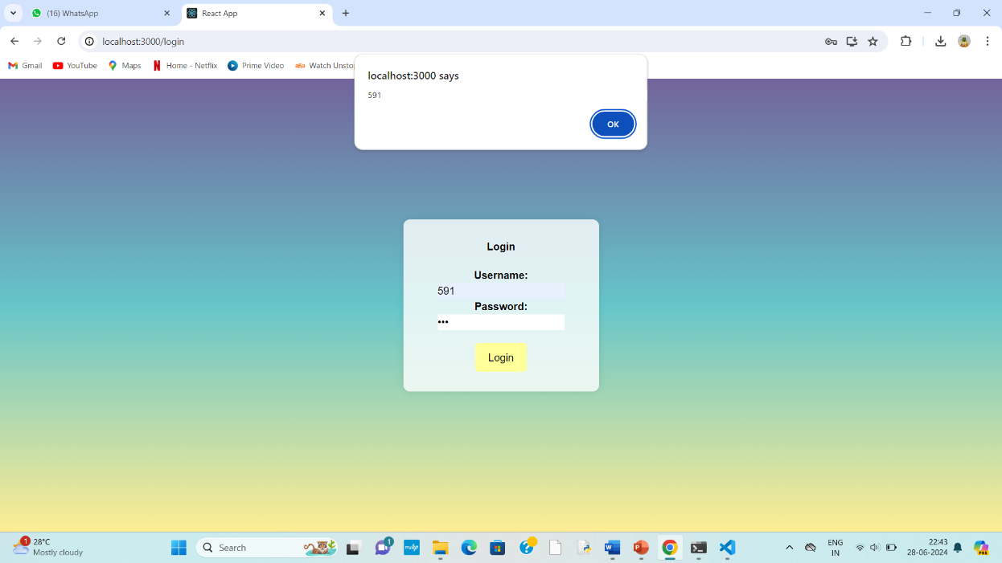

After logging in with credentials the following page will be displayed

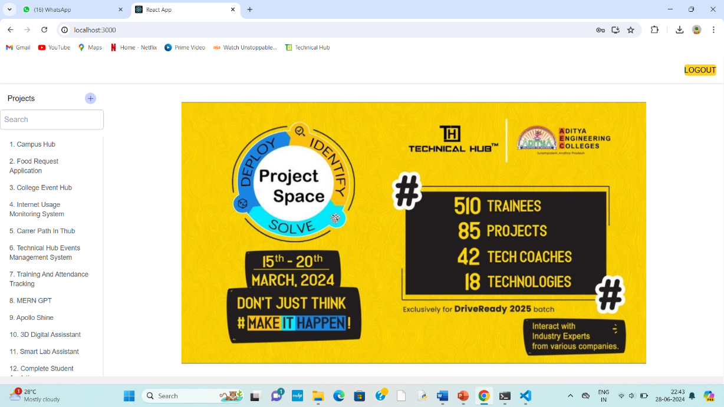

Later on,users can create a project by entering a project title and description.

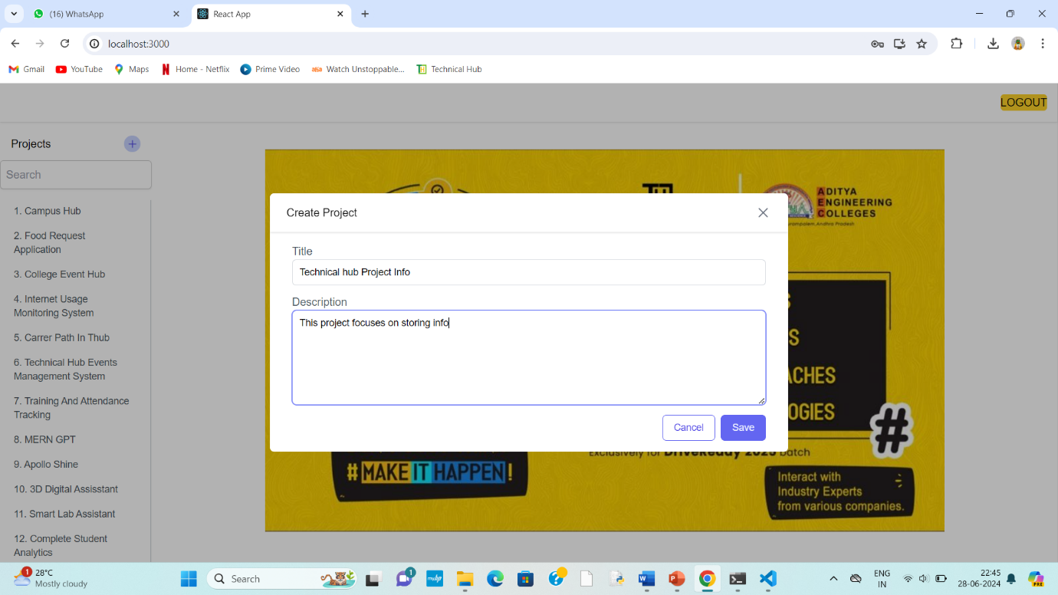

Once a project is created, users can fill in details under five headings: "Team Members," "Mentor," "Requested," "In Progress," and "Done." This structure ensures that all aspects of the project are comprehensively covered and easily accessible.

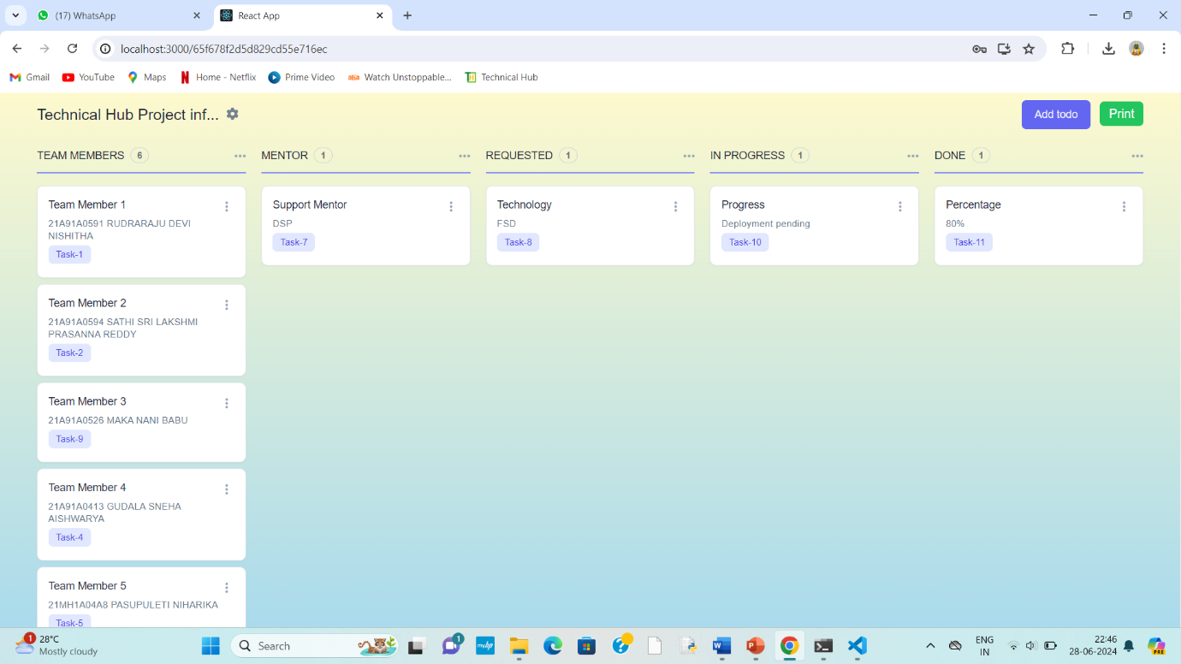

Users have the flexibility to edit or delete project details as needed, ensuring the information is always current and relevant.

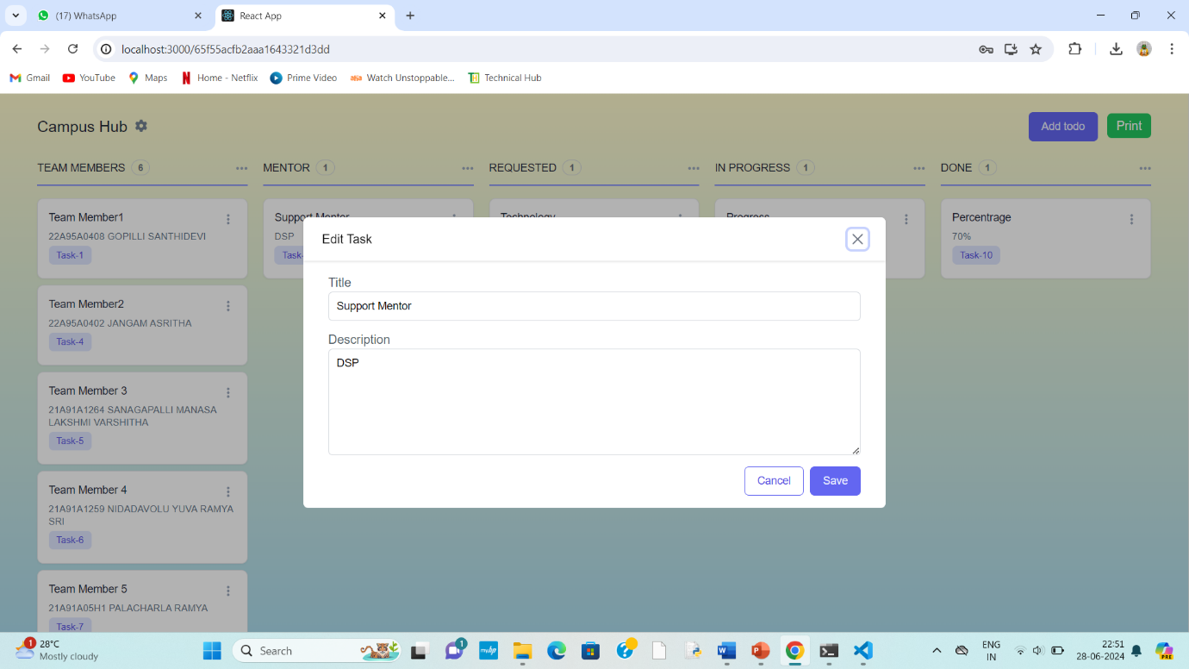

Additionally, the platform offers the option to print project details for offline review or presentation purposes.

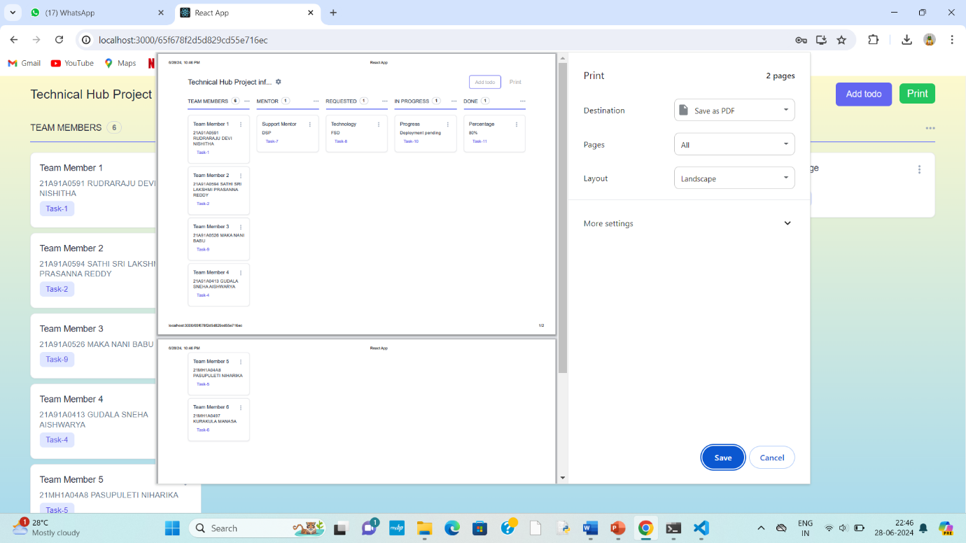

On the backend, we stored all project information in a robust database, ensuring data integrity and security. This setup allows for efficient data retrieval and management, supporting the platform's smooth operation. The database structure is designed to handle numerous projects and users simultaneously, maintaining performance and reliability. By centralizing project details in this manner, the website enhances organization, collaboration, and productivity within the technical community.

**Technologies Used:**

**Frontend:**

Javascript

Html

CSS

React js

**Backend:**

Node js

Mongodb

Express js

**Functionalities:**

1. **Project Listing:**
   * Users can view a comprehensive list of all projects stored within the technical hub, categorized by type (project space) or projects related to college (major, minor).
2. **Project Overview:**
   * Upon clicking on a project title, users are presented with a clear overview displayed in five columns: "Team Members," "Mentor," "Requested," "In Progress," and "Done."
3. **Progress Tracking:**
   * Each project's status is easily trackable through the platform, allowing users to monitor progress from initiation to completion.
4. **Real-time Updates:**
   * Users can edit and update project details, ensuring that information remains current and reflective of the project's status.
5. **User Management:**
   * Secure login and user management system to ensure that only authorized users can access and modify project details.

**CLOUD SERVICES :**

**OCI Compute Instances**

Once you've found the Automation Anywhere template or image on the Marketplace, you can deploy it on OCI Compute instances

**Networking Services**

Depending on your deployment requirements, configure networking services such as VCN, subnets, security lists, and internet gateways to ensure connectivity for your Automation Anywhere deployment.

**Storage Services**

You may need storage services like Object Storage or Block Volumes to store data and artifacts required by your Automation Anywhere bots**.**

**Integration Service**

Oracle Cloud offers integration services that allow you to integrate Automation Anywhere with other Oracle Cloud services or third-party applications

**Conclusion:**

The Technical Hub Project Info platform serves as a comprehensive solution for managing projects within technical hubs and educational institutions. It centralizes all project-related data, including details on team members, mentors, technologies used, project progress, and completion percentages, ensuring that information is easily accessible and up-to-date. This enhances organization, collaboration, and communication among stakeholders, reducing the risk of miscommunication and project delays. The platform's real-time update feature and progress tracking allow administrators to make informed decisions quickly. Additionally, the ability to print and export project details facilitates easy sharing of reports. Overall, this platform streamlines project management, promoting efficiency and successful project completion

**Main Motto: "Streamlining Project Management for Technical Hubs and Educational Institutions"**

Top of Form

+